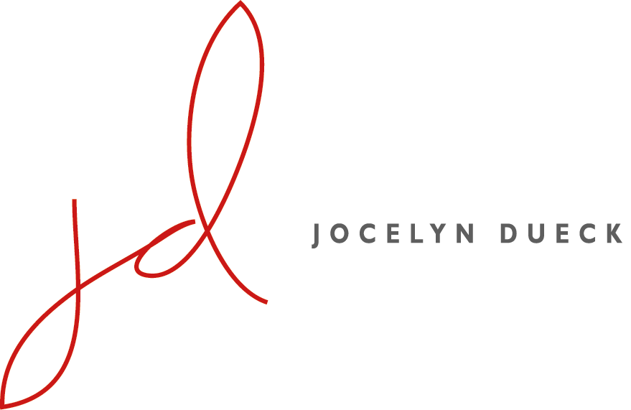

Training And Education
D.M.A., Collaborative Piano, Margo Garrett, professor, University of Minnesota, 2004
M.M., Collaborative Piano, University of Minnesota, 2001
B.A., Piano Performance, University of Minnesota, 1994
Tanglewood Music Center Fellow; Lenox, Massachusetts, 2004

Highlight Performances
La Maison Française, February 2017. Durey Rediscovered. Premieres of four unpublished works by Les Six composer Louis Durey together with Jesse Blumberg, William Burden, and Sidney Outlaw.
Brooklyn Historical Society, October 2013. For Britten in Song, partnered with Grammy Award nominees New York Polyphony and Wigmore Hall Song Competition first prize-winner Martha Guth on this Five Boroughs Music Fesitval celebration of Britten’s centennial.
WNYC’s Greene Space, Manhattan, December 2012, an American Opera Projects presentation of John Glover and Kelley Rourke’s one-act opera Our Basic Nature; baritone Andrew Wilkowske and ensemble REDSHIFT.
Huihuang Entertainment Agency, China, 10-city tour of China with Dueck Three, May-June 2007.
Teaching and Experience
Carnegie Mellon School of Music, Assistant Teaching Professor, Collaborative Piano, 2017- present
The Metropolitan Opera Lindemann Young Artist Program, English Diction preparation, recitals, 2017
The Juilliard School, English Diction preparation, The Rape of Lucretia, 2015; English Diction, Pre-college; French language preparation, L’enfant et les sortilèges, 2016; English and Scots preparation, curtain raiser.
Manhattan School of Music, Music Director, Sophomore Performance Class; Italian Diction, present; English and German coach, Opera Scenes program, 2015-2016, German Diction, 2013-14
Mannes College The New School for Music, Adjunct Professor 2008-present; German Lieder and American Art Song
Bard Conservatory, Visiting lecturer, Italian Diction, Vocal Arts Program, March – May, 2014 and 2016
NYU, Adjunct Assistant Professor, Italian, English, German and French Diction; faculty coach 2006-2010
L’Académie Internationale d’Eté de Nice, July-August 2017. Faculty coach - Lorraine Nubar & Dalton Baldwin’s program.
Recordings
Durey Rediscovered; the unpublished song cycles of Louis Durey (1888-1979); in process. New Focus Recordings.
Jesse Blumberg, Sidney Outlaw, baritones; Bill Burden, tenor; Adriana Zabala, mezzo-soprano
Adam Abeshouse, producer; Jocelyn Dueck, producer and pianist

The Lay of the Love and Death Lisa Bielawa, composer; Innova Records 2015 release
Jesse Blumberg, baritone, and Colin Jacobsen, violin
SUNY Purchase, Adam Abeshouse, sound engineer

Five Borough Songbook: 20 compositions by 20 composers, GPR Records 2012 release
Martha Guth, soprano, Jamie van Eyck, mezzo, David Adam Moore and David McFerrin, baritones, Keith Jameson and Alex Richardson, tenors; The New York Times deemed the pianists “solid, colorful accompanists” and the singers “strong individually…a finely balanced ensemble.”
Collaborative Experience
Seattle Opera, pianist/coach, May 2008, February 2009, April 2010
Glimmerglass Opera, Music Staff Pianist/Coach, 2005-2010
Two Sides Sounding, founding member, artistic director and pianist, 2005-2012
American Opera Projects, Pianist/Coach, February-March 2007, December 2010; language prep 2015
Tanglewood Music Center, Assistant Conductor, A Midsummers Night’s Dream, pianist and supertitles, 2004
Languages
German: resided in Berlin, Germany, 1998; studies from age six through adulthood
Italian: studies at the Universitá per Stranieri, private diction lessons, Perugia; University Language Center
French: dissertation research Paris, France, 2003; Teachers Thomas Grubb and Pierre Vallet; studies at the University of Minnesota, Alliance Française in Nice, France, University Language Center, Minneapolis. Continued scholarship of the works of Louis Durey and work in France.
Selected Awards and Honors
Samuel Sanders Collaborative Artist Award, Classical Recording Foundation, January 2016
Brooklyn Arts Council, 2011, Funded by the New York State Council on the Arts Decentralization Program (NYSCA Regrant), A Coney Island of the Mind: Two Sides Sounding
Canadian Department of Foreign Affairs and International Trade grant, March 2007, Dueck Three.
Doctoral Dissertation International Research Fellowship, University of Minnesota, 2003
Office of International Programs travel grant, University of Minnesota, 2001

